**Circles**

# What is a Circle?

A **circle** is a collection (set) of all those points in a plane, each one of which is at a constant distance from a fixed point in the plane.

The fixed point is called the **center** and the constant distance is called the **radius** of the circle.

# Division of a plane using circle

* + A circle divides the plane on which it lies into three parts: inside the circle, the circle and outside the circle.
  + All the points lying inside a circle are called its **interior points** and all those points which lie outside the circle are called its **exterior points**.
  + The collection (set) of all interior points of a circle is called the **interior of the circle** while the collection (set) of all exterior points of a circle is called the **exterior of the circle**.

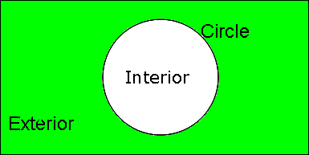

# Chord, diameter and secant of a circle

* + A line can meet a circle at the most in two points and the line segment joining two points on a circle is called a **chord** of the circle.
  + A chord passing through the center of the circle is called a **diameter** of the circle. A diameter of the circle is its longest chord. It is equal to two times the radius.
  + A line which meets a circle in two points is called a **secant** of the circle.

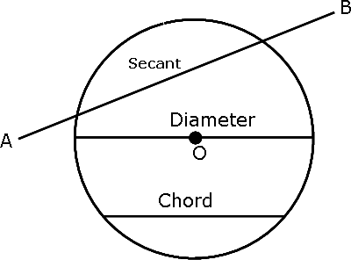

# Arc of the circle

* + A (continuous) part of a circle is called an **arc** of the circle. The arc of a circle is denoted by the symbol ‘ ’.
  + When an arc is formed, it divides the circle into two pieces (between the points A and B), the smaller one and the longer one. The smaller one is called the **minor arc** of the circle, and the greater one is called the **major arc** of the circle.

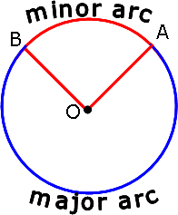

# Circumference and Semi-circle

* + The length of the complete circle is called the **circumference** of the circle.

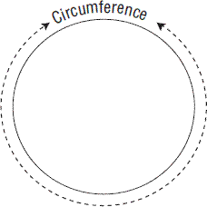

* + One-half of the whole arc (circumference) of a circle is called a **semi-circle**.

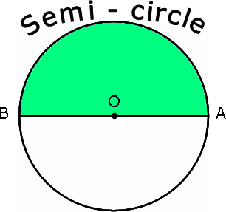

# Central angle and Degree measure

* + Any angle whose vertex is centre of the circle is called a **central angle**.
  + The **degree measure of a minor arc** is the measure of the central angle subtended by an arc.
  + The degree measure of a circle is 360°. The degree measure of a semi-circle is 180° (half of the circle).
  + The degree measure of a major arc is (360° - *θ*°), where *θ*° is the degree measure of the corresponding minor arc.

# Congruent circles and arcs

* + Two **circles** are said to be **congruent** if and only if either of them can be superposed on the other so as to cover it exactly.
  + Accordingly, two **arcs** of a circle (or of congruent circles) are **congruent** if either of them can be superposed on the other so as to cover it exactly.

# Sector of a circle

* + The part of the plane region enclosed by an arc of a circle and its two bounding radii is called

**sector** of a circle.

* + If the central angle of a sector is more than180 , then the sector is called a **major sector** and if the central angle is less than 180 , then the sector is called a **minor sector**.

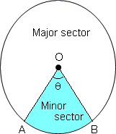

# Segment of a circle

* + A chord of a circle divides it into two parts. Each part is called a **segment** of the circle.
  + The part containing the minor arc is called the **minor segment**, and the part containing the major arc is called the **major segment**.

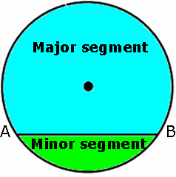

# Angle subtended by a chord and perpendicular drawn to a chord

* + Equal chords of a circle subtend equal angles at the centre.

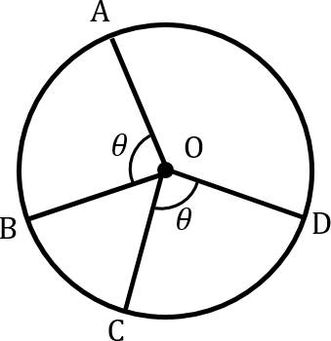

* + If the angles subtended by the chords of a circle at the centre are equal, then the chords are equal.
  + In a circle, perpendicular from the center to a chord bisects the chord.
  + A line drawn through the centre of a circle to bisect a chord is perpendicular to the chord.
  + 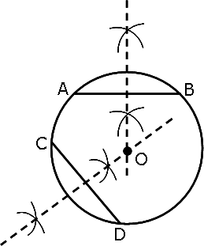Perpendicular bisectors of two chords of a circle, intersect each other at the centre of the circle.

# Number of circle through one or more point(s)

* + An infinite number of circles can be drawn through a given point, say P.

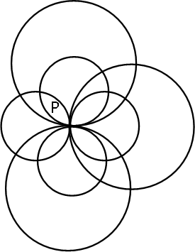

* + An infinite number of circles can be drawn through two given points, say A and B.

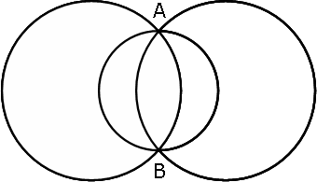

* + One and only one circle can be drawn through three non-collinear points.

# Distance of chord from the centre

* + The length of the perpendicular from a point to a line is the distance of the line from the point.
  + Equal chords of a circle (or of congruent circles) are equidistant from the centre (or centres).
  + Chords equidistant from the centre of a circle are equal in length.

# Angle subtended by an Arc of a circle

* + The angle subtended by an arc at the centre is double the angle subtended by it at any point on the remaining part of the circle.
  + If two chords of a circle are equal, then their corresponding arcs are congruent.
  + Conversely, if two arcs are congruent, then their corresponding chords are equal.
  + Congruent arcs (or equal arcs) of a circle subtend equal angles at the centre.

# Con-cyclic points

* + If a line segment joining two points subtends equal angles at two other points lying on the same side of the line containing the line segment, the four points are con-cyclic, i.e., they lie on the same circle.
  + Angles in the same segment of a circle are equal.

# Angle in a semi-circle

* + An angle in a semi-circle is a right angle.
  + The arc of a circle subtending a right angle at any point of the circle in its alternate segment is a semi-circle.

# Cyclic quadrilaterals

A quadrilateral, all the four vertices of which lie on a circle is called a **cyclic quadrilateral**. The four vertices *A, B, C* and *D* are said to be concyclic points.

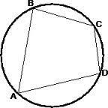

# Properties of cyclic quadrilateral

* + The opposite angles of a cyclic quadrilateral are supplementary i.e. their sum is 180°.
  + If the sum of any pair of opposite angles of a quadrilateral is 180°, then the quadrilateral is cyclic.
  + Any exterior angle of a cyclic quadrilateral is equal to the interior opposite angle.
  + The quadrilateral formed (if possible) by the internal angle bisectors of any quadrilateral is cyclic.
  + The line of centres of two intersecting circles subtends equal angles at the two points of intersection.

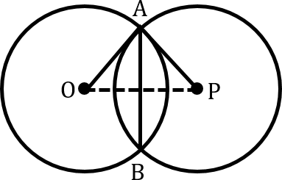

In the figure, angle OAM = angle PAM.

* + If diagonals of a cyclic quadrilateral are diameters of the circle through the vertices of the quadrilateral, then it is a rectangle.
  + If the non-parallel sides of a trapezium are equal, then it is cyclic.